***Virginia Junior Classical League***

*presents this*

Certificate of Excellence

*to*

Liza Cobey

*of*

James Monroe High School

*for*

*4th Place in Other*

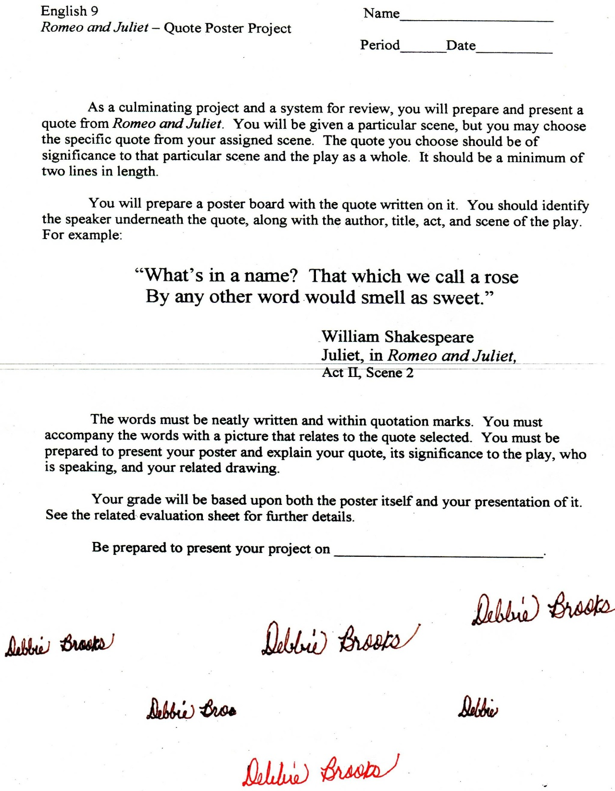

Microsoft Office Signature Line...

*a.d. viii Kal. Dec. MMDCCLXVII A.U.C. 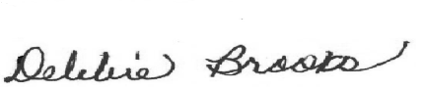*

***Virginia Junior Classical League***

*presents this*

Certificate of Excellence

*to*

Kelly Ngyuen

*of*

James Monroe High School

*for*

*5th Place in Oil*

**

Microsoft Office Signature Line...

*a.d. viii Kal. Dec. MMDCCLXVII A.U.C. *

***Virginia Junior Classical League***

*presents this*

Certificate of Excellence

*to*

Luke Romero

*of*

James Monroe High School

*for*

*6th Place in Ornaments*

**

Microsoft Office Signature Line...

*a.d. viii Kal. Dec. MMDCCLXVII A.U.C. *

***Virginia Junior Classical League***

*presents this*

Certificate of Excellence

*to*

Ally Kuster

*of*

James Monroe High School

*for*

*6th Place in Textiles*

**

Microsoft Office Signature Line...

*a.d. viii Kal. Dec. MMDCCLXVII A.U.C. *

***Virginia Junior Classical League***

*presents this*

Certificate of Excellence

*to*

Emma Dolby

*of*

James Monroe High School

*for*

*7th Place in Ornaments*

**

Microsoft Office Signature Line...

*a.d. viii Kal. Dec. MMDCCLXVII A.U.C. *

***Virginia Junior Classical League***

*presents this*

Certificate of Excellence

*to*

Natalie Luffman

*of*

James Monroe High School

*for*

*7th Place in Illustrated Quotations*

**

Microsoft Office Signature Line...

*a.d. viii Kal. Dec. MMDCCLXVII A.U.C. *